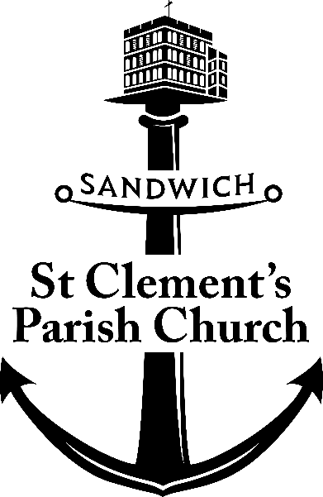

**HIRING RATES**

**ST CLEMENT’S CHURCH HALL**

**HIRE OF ST CLEMENT’S CHURCH HALL**

**FOR CLASSES, CLUBS, ACTIVITIES etc.**

£15 (per hour)

Weekend morning or afternoon £60

Saturday evening £160

Baptism Parties/Funeral Receptions: £60

Charity events (e.g. quiz night): £65

*Includes use of the kitchen for light refreshments*

*(use of kitchen for hot food preparation £50)*

*We request a returnable deposit of £100 to secure a party booking*

For further information or to book the hall please contact our Parish Administrator:

[admin@stclementsandwich.org.uk](mailto:admin@stclementsandwich.org.uk) T:02030894745

October 2024