|  |  |  |
| --- | --- | --- |
|  |  |  |

***St Clement’s Church Sandwich Parish Visit with St Clement’s Church Choir to London’s Southwark Cathedral on Saturday 2nd August 2025***

The choir has been invited to sing Choral Evensong at Southwark Cathedral on Saturday 2nd August. Coach travel for the choir and supporters has been arranged and will leave the Quay at Sandwich at 10.00am to travel directly to Southwark and arriving around midday. Entrance to the Cathedral is free and there are opportunities to visit other nearby attractions such as the bustling Borough Market, The Shard, HMS Belfast, Shakespeare’s Globe Theatre and Tower Bridge. The choir will be in rehearsal from 2.30pm. Evensong is at 4.00 pm.

After Evensong we have arranged a pre-ordered meal (time tbc) in the Winchester Room of the George Public House in Borough High Street which is a short walk from the Cathedral. We intend to leave no later than 8pm (possibly sooner) to arrive back at Sandwich around 10pm.

We would be very pleased to have as many supporters as possible on this parish visit. Accordingly, the PCC have generously agreed to subsidise coach travel to enable the cost to be £15/head and paid in advance. If participating in the evening meal, you will also need to pay for that in advance.

A booking form and menu for the meal is overleaf. Please complete this and send either as a hard copy or scanned version to :-

*Julian Sampson 0777 333 2517 (*[*sampson@supanet.com*](mailto:sampson@supanet.com)*)*

*Derek Kirkaldie 0754 566 1551 (d.kirkaldie@stclementsandwich.org.uk)*

Payment needs to be made in advance and bank details are set out on the form. Ideally payment can be made electronically, but if not, cheques or cash are acceptable. Please make sure that you get a receipt from us to acknowledge your booking.

We hope that you will join us for what will be another enjoyable parish event and supporting our choir in singing at this often-forgotten London cathedral. Coach places will be allotted on a first come first served basis and subject to space being available. Booking needs to be completed by 20th July.

Julian and Derek

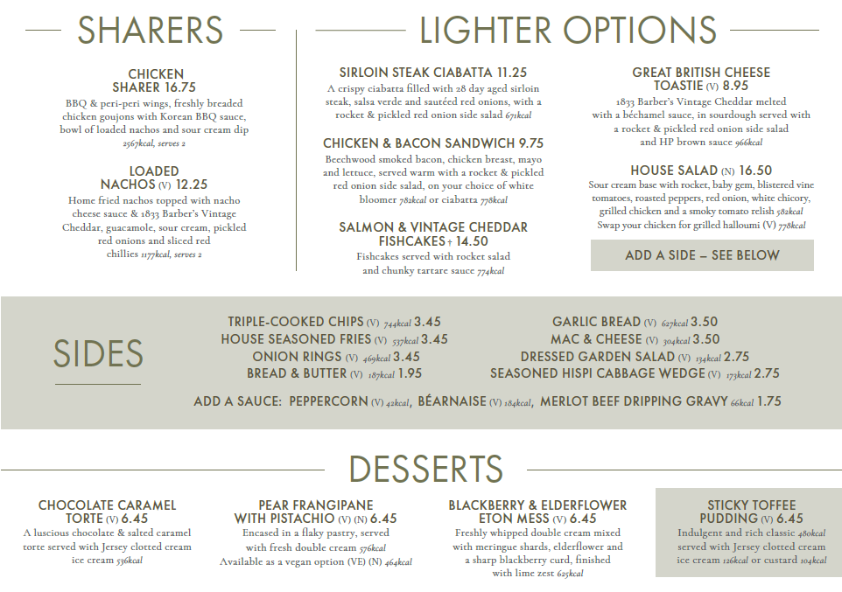

Please return this Booking Form to Julian Sampson or Derek Kirkaldie at St Clement’s:-

**Visit to Southwark Cathedral and Meal in the Winchester Room at The George Borough High Street London on Saturday 2nd August 2025.**

Names ……………………………………………………………………………………………………..

………………………………………………………………………………………………………

Address ……………………………………………………………………………………………………………

Email ………………………………………………… Telephone …………………………………………….

Meal options:-

Starter …………………………………………………………………………………. £………

Starter …………………………………………………………………………………. £………

Main …………………………………………………………………………………. £………

Main …………………………………………………………………………………. £………

Dessert …………………………………………………………………………………. £………

Dessert …………………………………………………………………………………. £………

Any extra food costs (based on menu detail) £……….

Catering Tip at £2/hd £……….

Number of coach spaces required …… (number) at £15/head £……….

Total £……….

Any dietary information to be passed on to the George? ………………………………………..

(Any drinks ordered with the meal are to be paid separately)

Please attach a cheque payable to Mr J M Sampson, pay by cash or remit electronically

To Lloyds Bank Sort Code 77-63-08

Account Mr J M Sampson and Mrs B M Sampson

Account No. 00491860

*Your order and payment will be receipted by email.*

*The finances of this trip are under the auspices of the PCC Treasurer.*

*Further details of the trip will be made available in late July.*